# Simulation Results

In this part, the simulation results we have carried out with the components we prefer after the theoretical calculations are given. The results we obtained belong to the circuit formed with the core (CF139EE2507) and MOSFETs (P60B4EL ,Rds,on=33m, Vds=40V, Id=60A) that we preferred in the simulation report process. Transformer parameters with detailed calculations in the Simulation report and used for simulation are as follows,

Also, in line with the information we obtained from the application notes, we created an RC snubber circuit by trying various resistor and capacitor values. In accordance with the values we can find in the market, we determined our capacitor as 47nF and our resistance as 5.6Ω.

When we made observations by placing the found non-ideality parameters in the simulation model, the results in the graphs below were obtained (Vin=12V, D=0.45, fsw=40kHz),

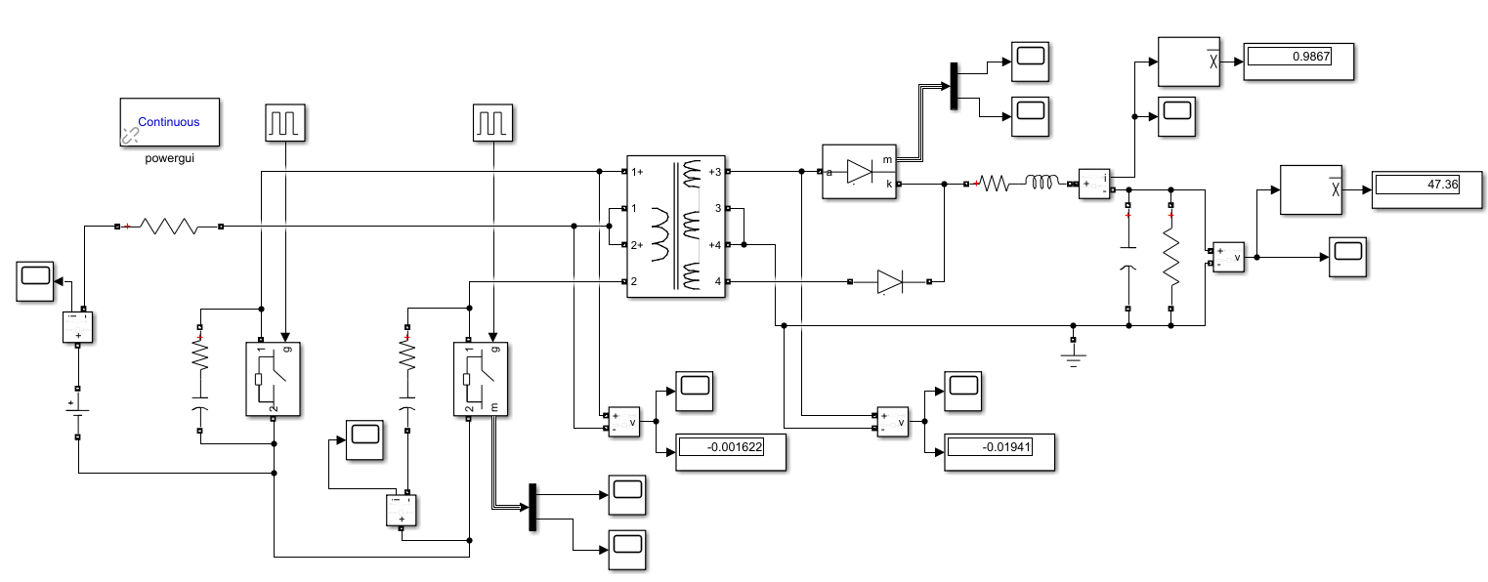

*Figure 10. Simulation model of the non-ideal push pull converter.*

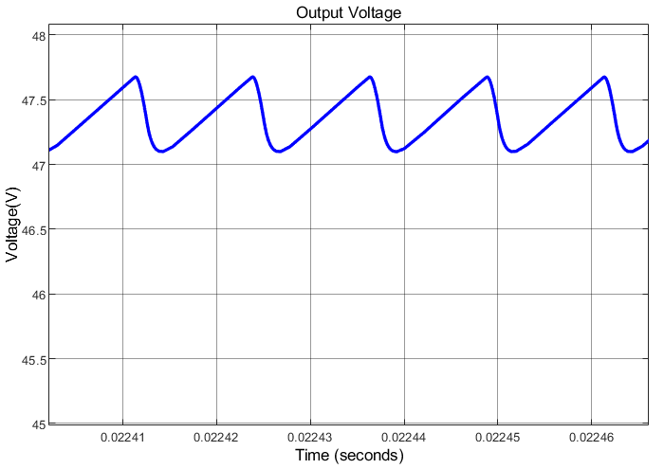

*Figure X. Output voltage waveform of non-ideal push-pull converter.*

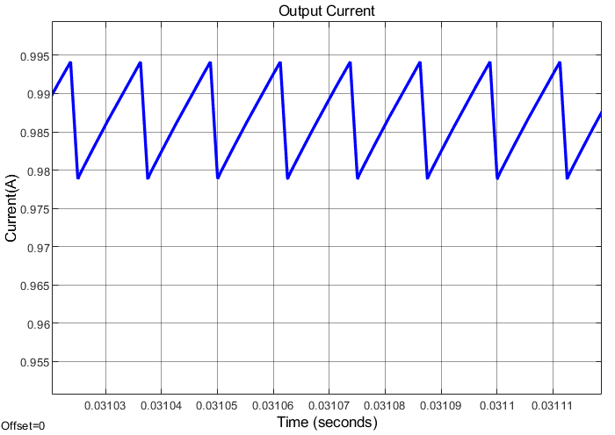

*Figure X. Output current waveform of non-ideal push-pull converter.*

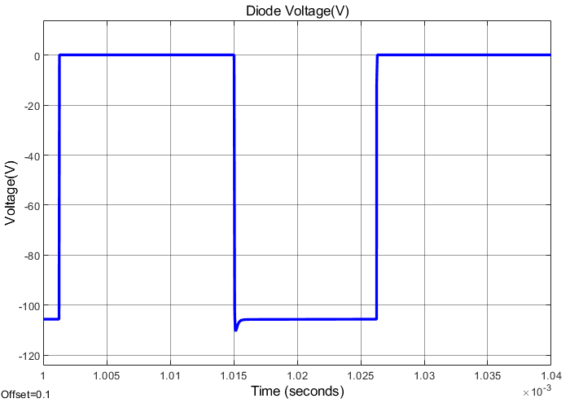

*Figure X. Voltage waveform of one of the diodes that is in the secondary side.*

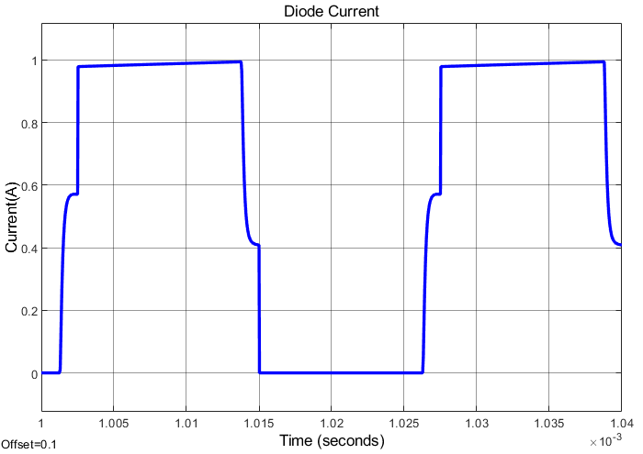

*Figure X. Current waveform of one of the diodes that is in the secondary side.*

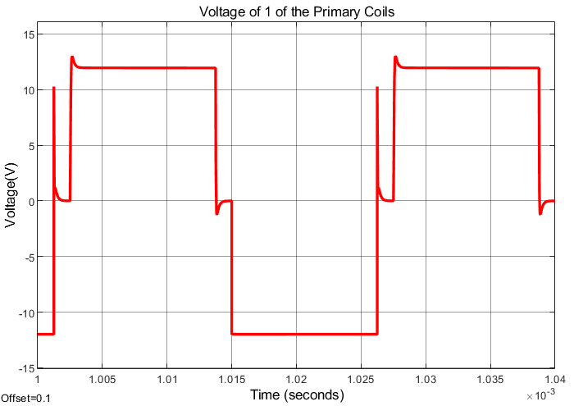

*Figure X. Voltage waveform of one of the primary coils.*

metin, diyagram, çizgi, öykü gelişim çizgisi; kumpas; grafiğini çıkarma içeren bir resim

Açıklama otomatik olarak oluşturuldu

*Figure X. Voltage waveform of one of the secondary coils.*

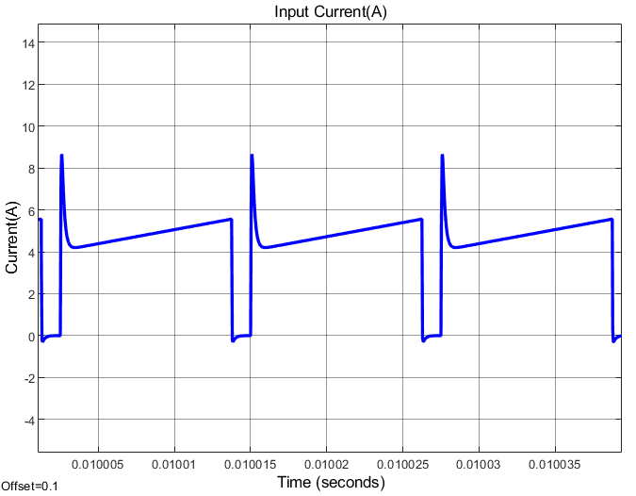

*Figure X. Input current waveform of the non-ideal push-pull converter.*

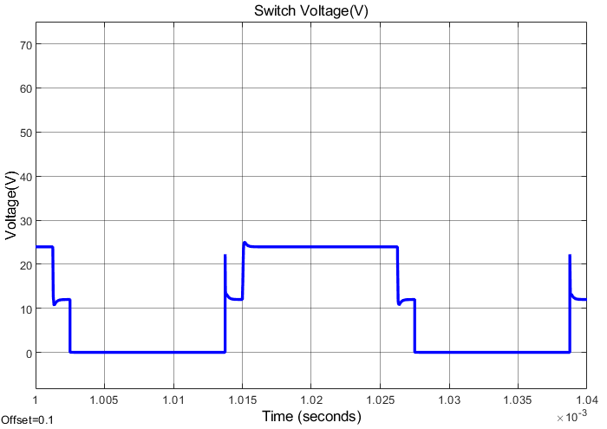

*Figure X. Voltage waveform of one of the switches in the primary side.*

As can be seen from the graphics, a slight decrease from desired level (48V) has been observed in our output voltage. In addition, the negative effects caused by the parameters that cause non-ideality in the transformer are reduced by using the snubber circuit.

After the circuit we created in line with all the parameters used for the simulation did not work as we wanted, the new components and parameters in this report were preferred in our prototype we created for the demo.

# Test Results

In this part, the results of the tests performed on the circuit created for the demo are given. The components preferred in the prototype and the parameters of the transformer produced are included in the previous parts of this report.

The biggest difference between the circuit created for the demo and the model created during the simulation report is that our transformer design has changed. Unfortunately, the circuit we created in line with the parameters we determined in the simulation report stage did not give the desired result and our output voltage was well below the desired value. In this direction, we started to examine the controller datasheet and the structure we created for feedback in more detail. After noticing that the minimum recommended switching frequency of our controller is 100kHz, we updated our switching frequency to 100kHz. Of course, with the changing switching frequency, our transformer parameters also changed. Despite the possibility that the core we preferred before was saturated, we recreated a transformer using 00K6527E060, one of the cores in the laboratory. In our later tests, we realized that the problem was not with the transformer, but with the operating voltage range of the controller. However, we did not make any changes to our transformer, staying true to the final design we created.

Although the input voltage level required for the controller to work properly in the datasheet is 12V, a minimum of 14V is recommended. Our push-pull converter, which we designed, starts to work as desired by increasing it to at least 14V levels after the input is given at low voltages.

While performing the tests, two outputs on the power supply were connected in parallel and used as input voltage source. The test results of our prototype we created for our demo are given in the following figures. **(CH1:input voltage, CH2:input current, CH3:output current, CH4: output current)**

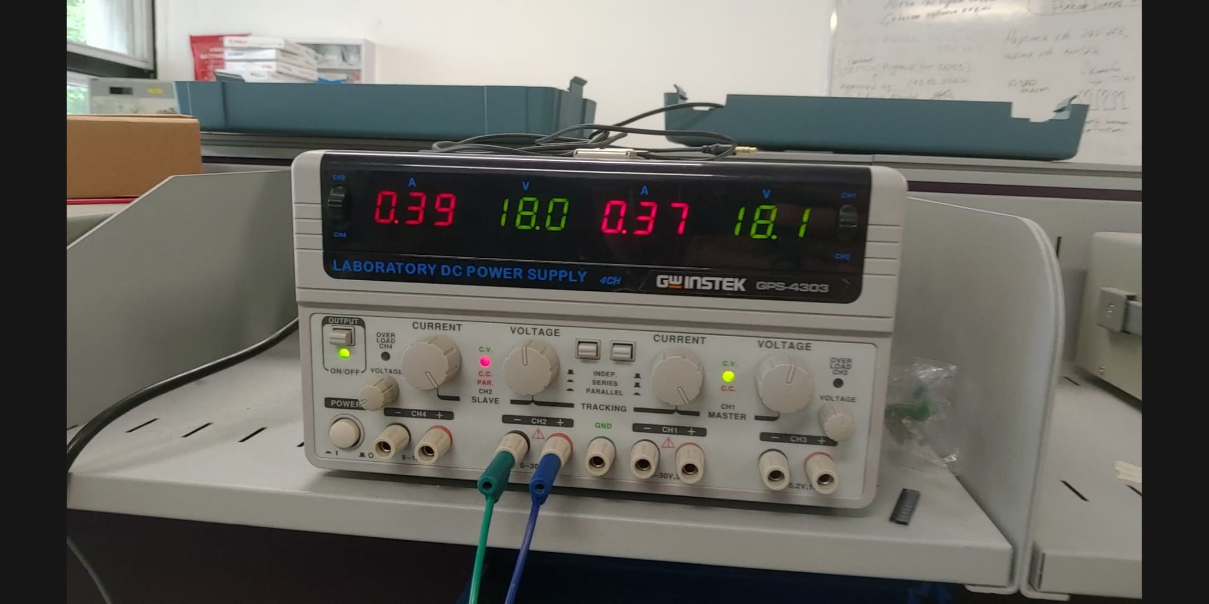

Figure x. Input voltage (18V) and currents for low load.

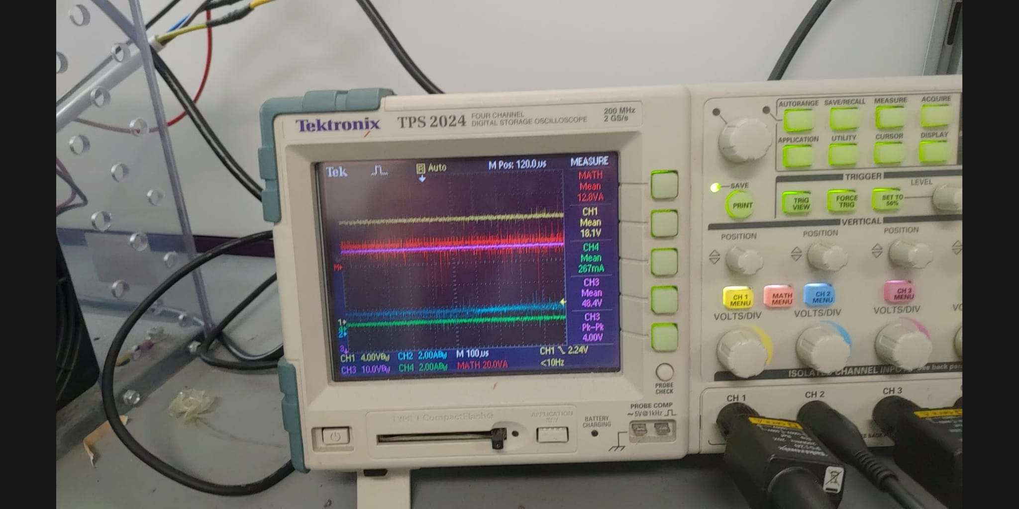

Figure x. Voltage and current measurements for 18V input with low load case.

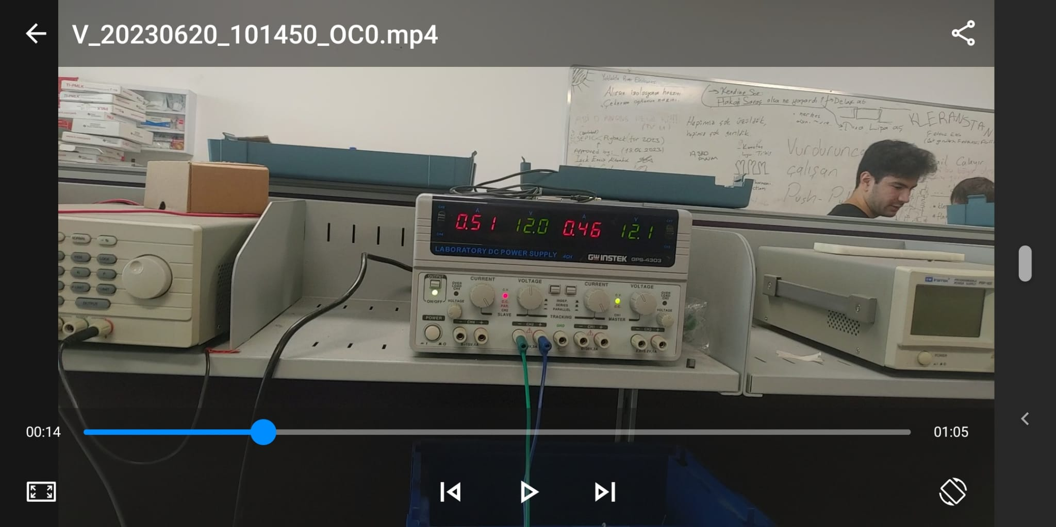

Figure x. Input voltage (12V) and currents for low load.

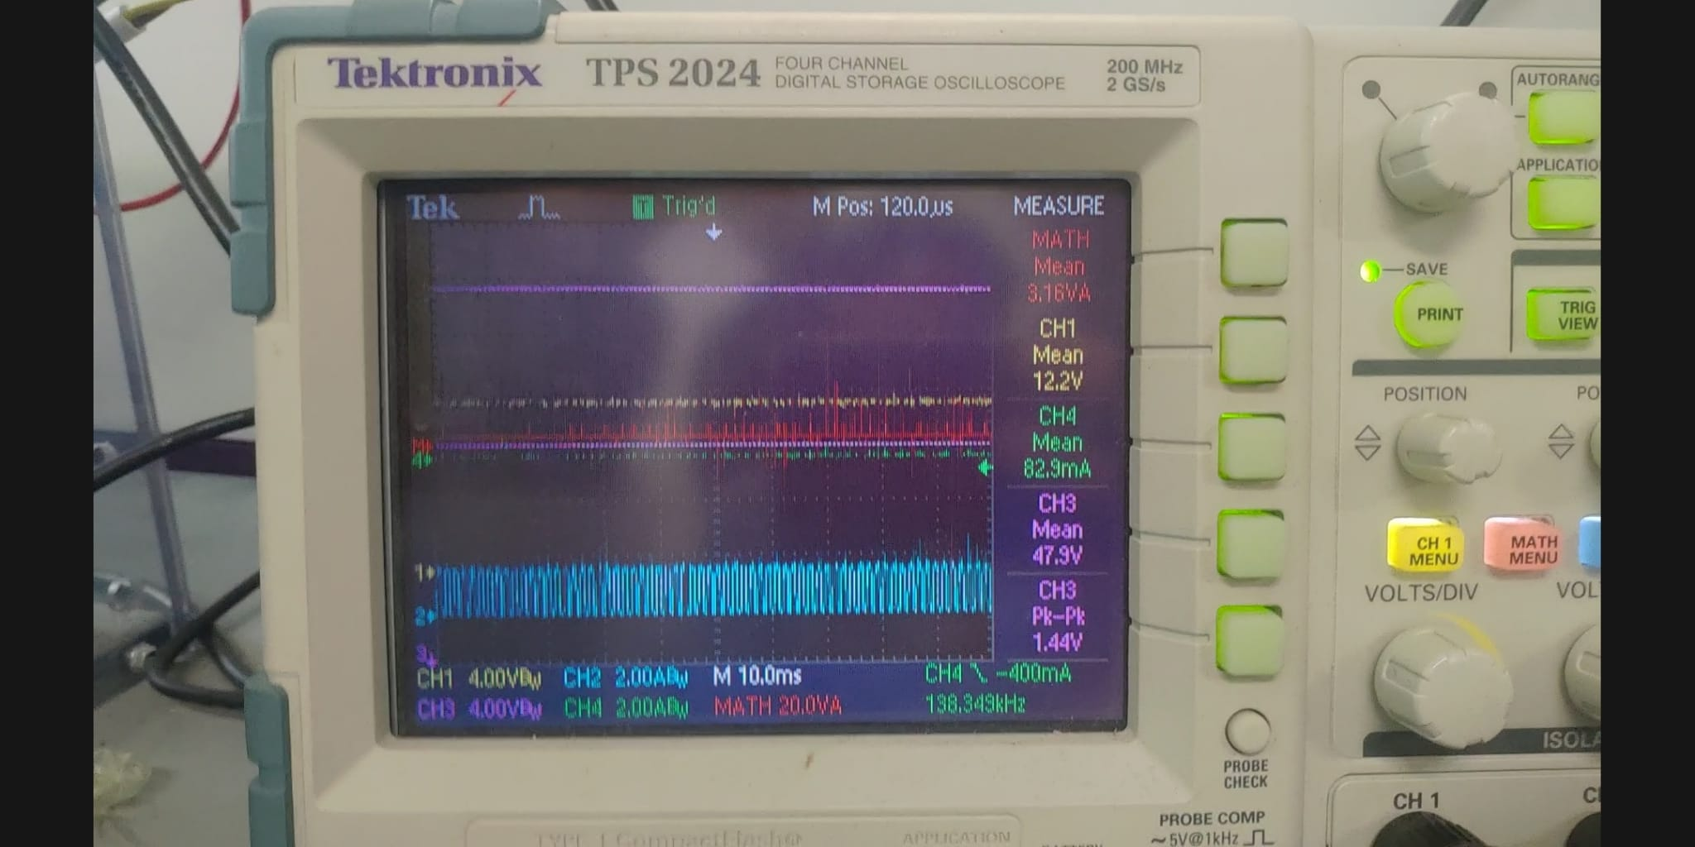

Figure x. Voltage and current measurements for 12V input with low load case.

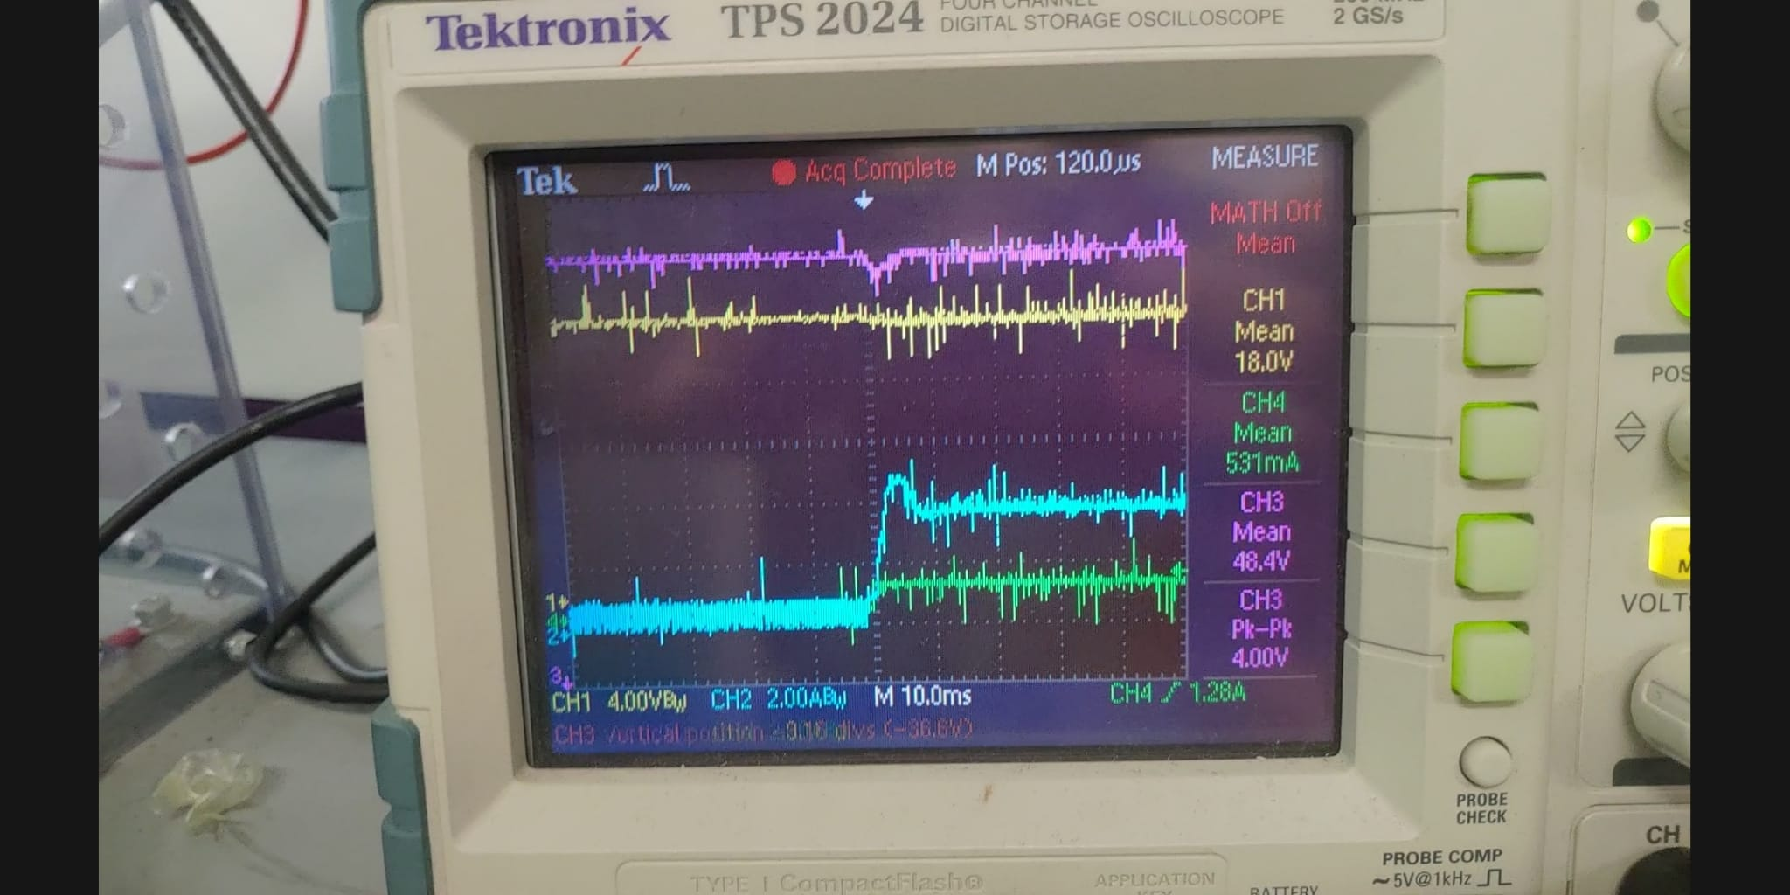

Figure x. Low load to high load transition with 18V input.

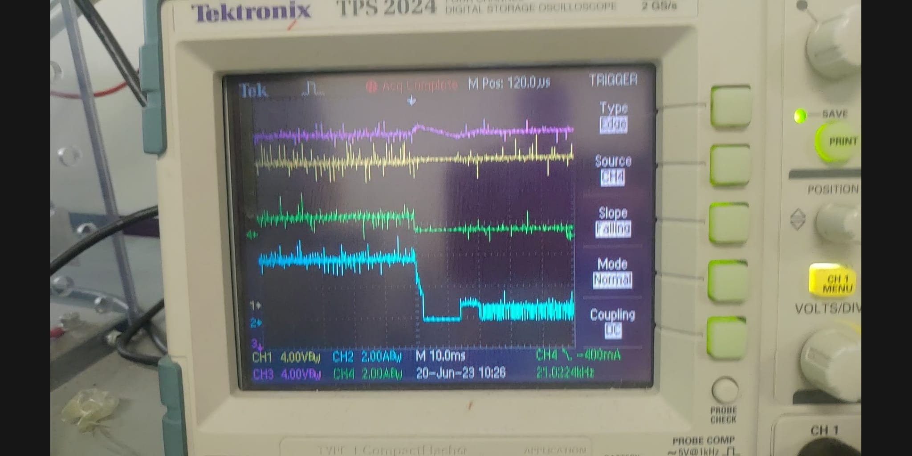

Figure x. High load to high load transition with 18V input.

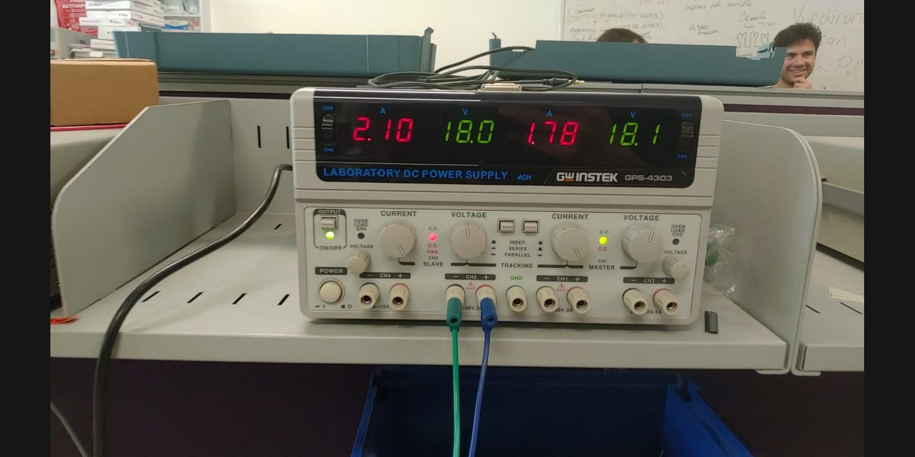

Figure x. Input voltage (18V) and currents for high load.

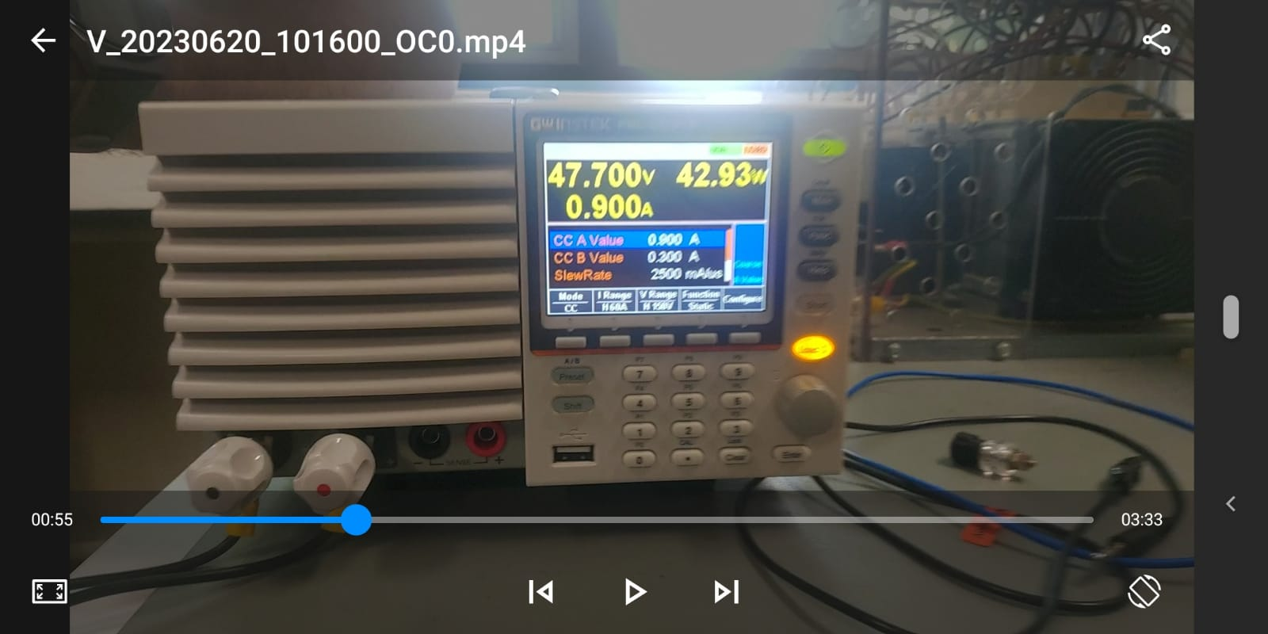

Figure x. Output load measurements for 18V input with high load case.

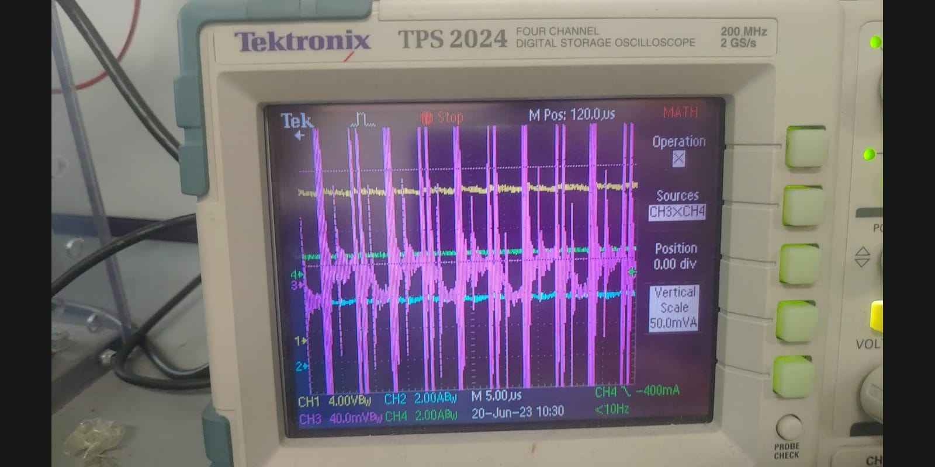

Figure Y. Output voltage ripple measurement.

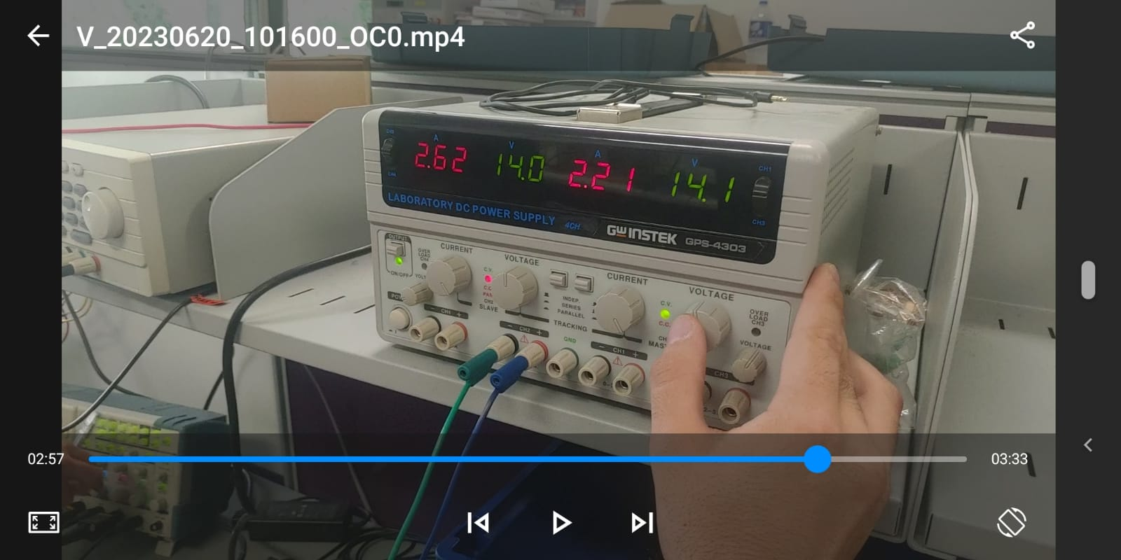

Figure x. Input voltage (14V) and currents for high load.

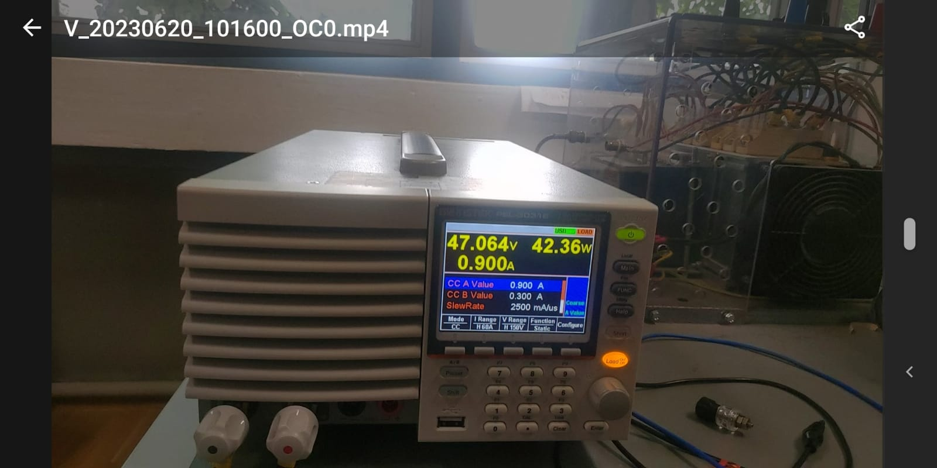

Figure x. Output load measurements for 14V input with high load case.

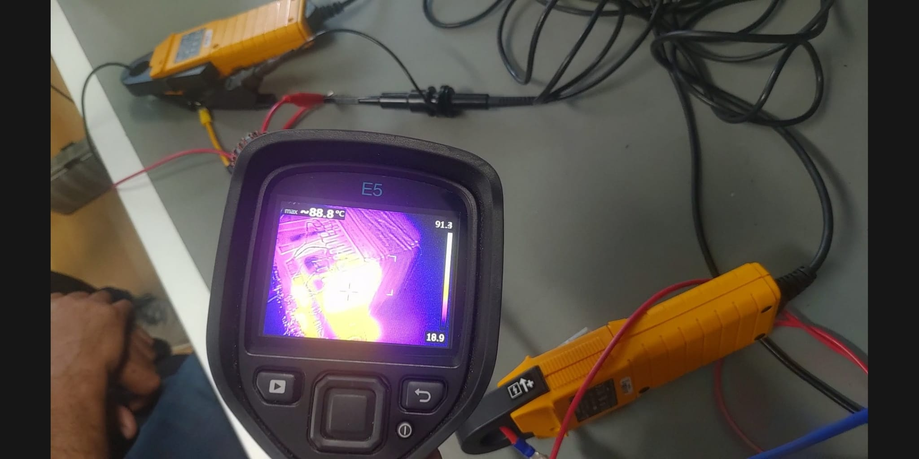

Figure x. Thermal camera image that taken after 18V input with high load case.

In addition, the highest temperature measurement (120oC) was observed for 12V input with high load case. However, it is not included in the report because its image cannot be obtained.

As can be seen from Figure Y, our output voltage ripple value is quite small (50mV) due to the capacitance value of our preferred output capacitors. From all the other measurement results we have obtained, we see that our controller successfully keeps the output voltage level in load and line regulation situations. However, a minimum of 14V input voltage was applied to take measurements at high load, as the controller shuts itself down because voltage is applied below 14V input voltage only at high load.